WHY IS THE AUDIT BEING CONDUCTED?

The audit makes certain that your claim has been paid correctly. If you received less or more than you should have been paid, an adjustment will be made.

The results of the audit give administrators of NH Employment Security information to use in improving the Unemployment Compensation programs.

EVERYONE OWNS
INTEGRITY

Program integrity is a top priority of the Unemployment Insurance (UI) Division.

Ensuring integrity of the UI program is a joint responsibility of claimants, employers and New Hampshire Employment Security.

The activities of the NHES Quality Control Unit help to ensure that New Hampshire Unemployment Law & Rules are administered properly, that benefits are paid correctly, and that the Unemployment Trust Fund is protected.

“BE AN ACTIVE PARTNER TO HELP IMPROVE PAYMENT ACCURACY”

IF YOU HAVE A QUESTION OR CAN OFFER MORE INFORMATION CALL

Phone 603-228-4134
Fax 603-229-4314

Quality Control Unit
Employment Security
45 South Fruit Street
Concord NH 03301-4857

TO REPORT POTENTIAL UNEMPLOYMENT FRAUD

Phone 1-800-852-3400
Extension: 84016

NHES 0065
R-4/15

QUALITY
CONTROL

INFORMATION
FOR

CLAIMANTS

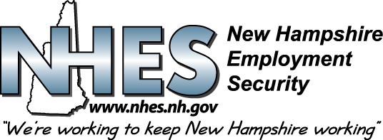

QUALITY CONTROL

WHAT IS IT?

Quality Control is a system designed to prevent both error and fraud in the Unemployment Compensation program.

Records of a "sample" group of claimants, selected each week at random, are audited to test the accuracy of the Unemployment benefit payments they receive.

WHAT DOES IT INCLUDE?

The audit consists of a review of employer records, agency actions, records and statements of the selected claimants.

- Eligibility is investigated
- Payroll records are verified
- Work search contacts are verified
- All actions and records relative to each claim are re-examined.

HOW ARE CASES SELECTED FOR AUDIT?

Each week "sample" claim records are chosen at random by the computer.

Selections are made from the list of claimants who received Unemployment Compensation payments during the preceding week.

Anyone who received unemployment benefits during that week may be chosen and, therefore, a claim may be audited more than once.

HOW IS IT DONE?

All employers from the beginning of the
base period through present are contacted to verify payroll records and the reason for becoming unemployed.

Claimants are notified that a particular week is being reviewed. A detailed questionnaire about the claim is mailed to the claimant for review.

Work search contacts listed by the selected claimants will be verified with employers.

HOW WILL YOU KNOW IF YOU ARE SELECTED?

You will be notified that a particular week is being audited after the week has passed, and you have been paid benefits.
You may receive the questionnaire in the mail, or
- You may be asked to meet with an auditor to review your case and fill out a detailed questionnaire about your claim.
- You may be asked to complete the questionnaire over the telephone with an auditor.
- If you have returned to work, the department asks that you still complete the questionnaire and return it.

In accordance with eligibility and reporting requirements under NH State law and rule, the failure to complete the questionnaire by the due date may result in a delay or denial of future benefits under EMP 501.14.

