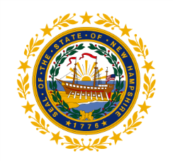

Welcome to

**NH Employment Security**

|  |
| --- |
| UNEMPLOYMENT COMPENSATION  **QUICK TIPS** |

**READ ME for answers to common questions and to minimize delays in processing your benefit payment.**

**TABLE OF CONTENTS**

Unemployment Compensation Page 3

Starting/Opening a Claim Page 4

Continuing a Claim/Weekly Claims Page 5

Weekly Benefit Amount Page 6

Getting the First Payment Page 7

Steps to Avoid Problems Page 8

Denial/Disqualification Reasons Page 9

Mandatory Meetings Page 10

Worksearch Page 11

Determinations Page 12

Appeals Page 13

Claims Representative Page 14

Overpaid Benefits Page 15

Misrepresentation/Fraud Pages 16-17

Most Common Mistakes Page 18

Local Office Resources Page 19

Equal Opportunity Page 20

Privacy Notice Page 21

NH Works Offices Page 22

Receipt Back Page

**UNEMPLOYMENT COMPENSATION**



Unemployment Compensation is an insurance program, supported by employer taxes, not employee deductions. It pays weekly benefits to individuals who qualify by meeting eligibility requirements.

Individuals who qualify must have:

* Worked in covered employment;
* Become unemployed through no fault of their own;
* Met eligibility requirements; and
* Filed proper and timely claims.

Covered employment is work for an employer who is subject to a state unemployment tax.

Most employers provide covered employment.

Some are not covered, such as churches and some church-run schools.

Unemployment “fault” is determined based on the reason you are no longer working for an employer. The Department, not your employer, makes this determination.

**How do I file a claim?**

You can go online from any computer – at home, at your local library, or at any NH Works Local Office. Help is available in the Local Office Resource Center if needed.

Our Website is: <http://www.nhes.nh.gov/> Click on “**File for Benefits**”.

If you are new to this program or have not filed since 2009, we would like to welcome you. Please choose “Create New Account”.

If you have filed before, choose “Existing User Log-in”.

Once you have established your account or signed into your account, click on “File a Claim”.



**Now that I filed an application, what’s next?**

***You must file weekly continued claims for your claim to remain active.***

Each week you will need to submit a weekly continued claim. This is how you request your benefits for each week you are totally or partially unemployed.

Each time you make this request, you will be asked a series of questions. These questions are to check on your continued eligibility.

Benefits requested cover one week only; a calendar week of Sunday through Saturday. You cannot file for a week until the week is over. You then have up to 7 days to file for that week.

Example:

Benefits requested cover Sunday March 6th through Saturday March 12th. This means that you must make your weekly claim request between Sunday March 13th and Saturday March 19th.

**What if I missed a week?**

You can go online and file a reopen for the current week, which will not include the week you missed. Visit or contact your local office for assistance if needed.

**How much will I get?**

[](http://www.bing.com/images/search?q=dollar+sign+images&view=detailv2&qpvt=dollar+sign+images&id=1E1C726988951C85306A228B8B075566E631342A&selectedIndex=22&ccid=qdeeDUFD&simid=608038353525411481&thid=OIP.Ma9d79e0d414322ba291b1fcb17e54ee1H0)

Your weekly benefit amount is based on how much you earned in the last 15 to 18 months. New Hampshire looks at your “base period”, which is normally the first 4 of the last 5 completed calendar quarters prior to the effective date of the claim.

The minimum earnings required for eligibility are $2800 ($1400 each in 2 separate quarters), which would result in a $32 weekly benefit amount. The more earnings in your base period, the higher your weekly benefit amount, to a maximum of $427 for $41,500 or more in earnings.

A detailed description of how the weekly benefit amount is determined, with examples and definitions, can be found on the claims filing website. The direct link for the “Amount & Duration of Benefits” document is:

<https://nhuis.nh.gov/claimant/index_wba.jsp>

**How long will it take to get my first payment?**

Benefits are paid only to eligible claimants.

Our goal is to pay eligible individuals benefits within 30 days.

How quickly an eligibility determination is made and payment is issued may depend on you.

Provide a complete work history record on your application. List all employment for the last 18 months, including in other states, self-employment, military and federal employment.

If you receive a Notice of Eligibility or call from this Department, you must respond as soon as possible and answer the questions to help move your claim through the process.



**STEPS TO AVOID PROBLEMS**



**Take these steps to avoid most claim problems:**

1. File your weekly claims on time.
2. Report any work and any payment.
3. Respond to documents before deadline.
4. Attend all scheduled mandatory meetings.
5. Look for work immediately and report weekly.
6. Keep a list with details about worksearch contacts.
7. Notify the Department if you declined offered work.

**Why would I not receive benefits?**

You could be denied one or more weeks because you did not meet the eligibility requirements or because of why you are no longer working for an employer.

Each case is different. The following are general lists of eligibility issues. For each week, you MUST:

* Be registered for work
* Be available for work
* Be able to work
* Be looking for work
* File claims on time
* Attend mandatory meetings
* Have a weekly benefit amount

You must NOT have:

* Exhausted your benefits for the benefit year
* Left your self-employment
* Been fired for misconduct
* Been fired for intoxication or illegal drugs
* Been fired for gross misconduct
* Refused suitable work
* Filed a fraudulent claim

Quitting your job or being involved in a voluntary strike may also be disqualifying, depending on the specific facts of your situation.

**Scheduled for a meeting?**



Once you file a claim, you will be scheduled for mandatory meetings at your NHWORKS Local Office. These meetings are required by law and are to help you get back to work.

You will receive notices to attend multiple meetings for various purposes. **You must attend all mandatory meetings to remain eligible for benefits.**

If you cannot make it to a scheduled meeting, you must contact the local office as soon as possible to reschedule your appointment.

**WORK SEARCH: Frequently asked questions**



Q. What kind of work do I need to look for?

*A. Look for work that you are qualified to do.*

Q. How many contacts do I have to make each week?

*A. Do what a reasonable person would do to find work. Make multiple contacts on different days of the week, using various methods. Report these contacts when you file your weekly claim for benefits.*

Q. I’m going back to work for my seasonal employer. Why do I have to look for work during the off-season?

*A. NH law states that you need to look for temporary work that is immediately available and not restricted by time of year or weather.*

Q. How does the Job Match System help me?

*A. This computer system matches your experience and the type of work you are looking for with employers looking to hire people.*

**ELIGIBILITY DETERMINATIONS**



After you file a claim, you will receive one or more determinations about your eligibility for benefits.

A “monetary” determination gives your weekly benefit amount for the benefit year. This determination does NOT guarantee payment.

A “non-monetary” determination allows or denies benefits based on other eligibility issues. All eligibility issues must be allowed to be paid benefits.

You are responsible for reading and understanding these determinations. You must meet all eligibility requirements to be paid benefits.

If you have any questions, please go to your Local Office or contact the Claims Representative for assistance.

1-800-685-6588 or (603) 228-4017

If you disagree with a determination you have appeal rights, which are included at the bottom of every determination.

**APPEALS**



**I Disagree with a Benefit Determination**

You may ask for a re-determination or file an appeal.

**read the appeal rights on the determination**.

* + The appeal request must be in writing.
  + File on-line, by email, fax, mail, or in-person.
* File within 14 days of the determination issue date.
* If you file after 14 days, include why it is late.
* If still unemployed, keep filing continued claims.
* Read all notices sent to you.
* To prepare for the hearing:
  + Read the Claimant’s Guide:

<http://www.nhes.nh.gov/forms/documents/appealb1.pdf>

* + Contact a Claims Representative

1-800-685-6588 or (603) 228-4017

* Attend the scheduled hearing.
* If you cannot attend, request to postpone.
* Contact the Appeal Tribunal Unit with questions.
  + [**appeals@nhes.nh.gov**](mailto:appeals@nhes.nh.gov)
  + PHONE: (603) 223-6140
  + FAX: (603) 223-6141

**I Disagree with an Appeal Tribunal Decision**

Appeal Decisions may be appealed further to:

* Commissioner (Request to Reopen)
* Appellate Board/Reconsideration
* NH Supreme Court

**CLAIMS REPRESENTATIVE**



**Who can help me?**

In addition to local office staff, the Department employs a Claims Representative. This person helps claimants with unemployment claim problems. This person also answers questions and gives advice about making the best case for a re-determination or for an appeal hearing. Under special circumstances, the Claims Representative may accompany you in the appeal hearing.

The Claims Representative may also review Department determinations to make sure that benefits have been properly processed according to law and rule.

The Claims Representative is not a lawyer. For legal advice or representation, you should contact an attorney or NH Legal Assistance.

To speak to a Claims Representative, call:

1-800-685-6588

or

(603) 228-4017

**OVERPAID BENEFITS**

If you have been found to be overpaid, you may need to repay the overpaid benefits. If you do not repay promptly, the Department may take collection actions.

The Department can offset future benefits or federal tax refunds. Future employer(s) may be required to garnish your wages. The Department can also put a lien on property or bank accounts.

Interest will accrue until the benefits are repaid.

If you need to set up a payment plan, please contact:

1-800-852-3400 extension 94391

or

603-229-4391

**Make arrangements today.**

**DON’T LET THIS HAPPEN TO YOU!**



**MISREPRESENTATION – FRAUD**

**Intentionally Providing False or Incomplete Information**

Willful false statements, misrepresentations or knowingly failing to disclose a material fact can have serious consequences.

If you lie or hide information to obtain or increase benefits paid to you or to another individual, you may be required to repay all the benefits for each affected week, pay an additional 20% penalty, and may be ineligible for benefits for up to a full year.

It can also constitute criminal fraud and you could go to jail.

If you receive benefits as a result of the misrepresentation, the criminal penalties are:

* Class A misdemeanor (up to $500);
* Class B felony (between $500 and $999.99);
* Class A felony ($1,000 or more).

To prevent fraud, NHES matches claim records with those of other state and federal agencies including the Social Security Administration.

Cross-Match programs compare wage records compiled in New Hampshire and nationally. NHES also compares state and national new hire reports to Unemployment Insurance (UI) records to ensure that claimants who have returned to work full-time are no longer collecting benefits and claimants who are working part-time are reporting accurate earnings.

.****

**MOST COMMON MISTAKES**

**Number 1 – Forgetting to file your weekly continued claim:**

Filing for benefits is a two-step process. First, you file the application where you supply all the necessary information to get things started. Then you MUST file weekly continued claims on time to keep your claim active.

**Number 2 - Not reporting income from part-time or**

**temporary work:**

You must report your gross wages—that’s the total amount earned before deductions—for the week you worked and earned them, not in the week you’re actually paid. You must report all earnings, whether from a part-time job, commissions, tips, bonus, self-employment, or an odd job like mowing lawns or babysitting.

**Number 3 – Waiting until you receive your first paycheck**

**before you stop filing for benefits:**

Be sure to notify NHES as soon as you begin working. If you start work, you are earning money that week, even if you have not yet been paid for it. Don’t wait until you receive your first paycheck to report the earnings and notify the Department that you’ve returned to work.

**Number 4 - Not being available to accept a new job:**

In order to collect benefits, you must continually certify that you are able, available and willing to accept suitable work. Possible conflicts like attending school during work hours, travel or childcare issues could limit your work availability and raise an eligibility question.

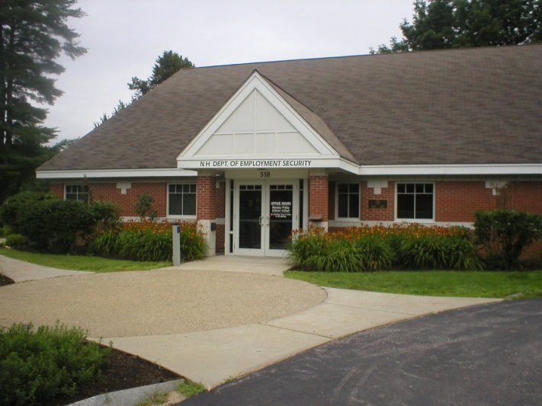**LOCAL OFFICE RESOURCES**

Computers, fax machines, booklets, and other resources are available to you at a NH Works office.

These resources are to help you find a job, update your resume, and stay up-to-date on what employers are seeking.

Information about starting your own business or applying for training in a new career is also available.

Language translation and auxiliary aids and services are available upon request for customers with disabilities.



**EQUAL OPPORTUNITY IS THE LAW**

It is against the law for New Hampshire Employment Security (NHES) to discriminate on the following basis: against any individual in the United States on the basis of race, color, religion, sex, national origin, age, disability, genetics, political affiliation or belief, and against any beneficiary of programs financially assisted under Title I of the Workforce Investment Act of 1998 (WIA) and its amendment Workforce Innovation and Opportunity Act of 2014 (WIOA), on the basis of the beneficiary’s citizenship/status as a lawfully admitted immigrant authorized to work in the United States, or his or her participation in any WIOA Title I financially assisted program or activity. NHES must not discriminate in any of the following areas: deciding who will be admitted, or have access to any WIOA Title I financially assisted program or activity; providing opportunities in, or treating any person with regard to such a program or activity; or making employment decisions in the administration of, or in connection with, such a program or activity. NH law also prohibits discrimination on the basis of sexual orientation, creed, marital or familial status.

**What to do if You Believe You Have Experienced Discrimination**

If you think that you have been subjected to discrimination, you may file a complaint within 180 days from the date of the alleged violation with either the NH Employment Security Local Office Manager or the Assistant to the Commissioner, NHES, 45 South Fruit Street, PO Box 1140, Concord NH 03301, phone number 603-228-4073 or the Director, Civil Rights Center (CRC), U.S. Department of Labor, 200 Constitution Avenue NW, Room N-4123, Washington DC 20210. If you file your complaint with the Local Office Manager or the Assistant to the Commissioner (NHES) you must wait either until NHES issues a written Notice of Final Action, or until 90 days have passed (whichever is sooner), before filing with the Civil Rights Center (see address above). If NHES does not give you a written Notice of Final Action within 90 days of the day on which you filed your complaint, you do not have to wait for NHES to issue that Notice before filing a complaint with CRC. However, you must file your CRC complaint within 30 days of the 90 day deadline (in other words, within 120 days after the day on which you filed your complaint with the recipient). If NHES does give you a written Notice of Final Action on your complaint, but you are dissatisfied with the decision or resolution, you may file a complaint with CRC. You must file your CRC complaint within 30 days of the date on which you received the Notice of Final Action. For Further Information see your NH Employment Security Local Office Manager.

**PRIVACY NOTICE**

The Privacy Act of 1974 requires that you be furnished this statement because you are being required to furnish your Social Security Account Number on the claim forms given to you. Your Social Security number is solicited under the authority of the Internal Revenue Code of 1954 (26 U.S.C. 85, 6011(a), 6050B and 6109(2). Disclosure of your Social Security number for this purpose is mandatory and must be entered on the forms you submit to claim unemployment compensation. Your Social Security Number will be used to report your unemployment compensation to the Internal Revenue Service as income that is potentially taxable; it will also be used as a record index for processing your claim, for statistical purposes, and to verify your eligibility for unemployment compensation. Should you refuse to disclose your Social Security number, your claim for unemployment compensation benefits cannot be processed.

Public Law 98-369 amended Title XI of the Social Security Act and requires that income and eligibility information such as your wages and benefit amount must be available to the agencies which administer the following programs: Workforce Innovation and Opportunity Act programs (effective 8/ 7/ 98) Aid to Families with Dependent Children (AFDC), Medicaid under Title XIX, Food Stamps, and any program approved under a plan approved under Titles I, X, XIV, or XVI of the Social Security Act.

RSA 282-A:118 and 282-A:123 cite specific circumstances under which information may or may not be disclosed by New Hampshire law.

**NH WORKS LOCATIONS**

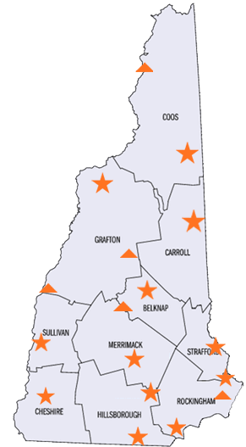Berlin 603-752-5500

Claremont 603-543-3111

Concord 603-228-4100

Conway 603-447-5924

Keene 603-352-1904

Laconia 603-524-3960

Littleton 603-444-2971

Manchester 603-627-7841

Nashua 603-882-5177

Portsmouth 603-436-3702

Salem 603-893-9185

Somersworth 603-742-3600

**Satellite Locations:**

Colebrook 603-237-5859

Exeter 603-772-9922

Franklin 603-934-2911

Lebanon 603-543-3111

Plymouth 603-536-1175

**RECEIPT OF UNEMPLOYMENT COMPENSATION QUICK TIPS**

In order to be properly informed, it is your responsibility to read and understand this booklet, and contact this department with any questions you may have.

If you have questions, please contact your NHWORKS Local Office or, if you are an interstate claimant, call 1-800-266-2252 to be connected to the Local Office that handles out of state claimants.

Additional details and information about the unemployment compensation program can also be found at [www.nhes.nh.gov](http://www.nhes.nh.gov)

**YOU MUST SIGN AND DATE THIS PAGE**

**RETURN ONLY THIS PAGE TO:**

**NHES, 45 SOUTH FRUIT ST, CONCORD NH 03301 OR TO YOUR NHWORKS LOCAL OFFICE.**

Your Name (please print) Last 4 SSN

Your Signature Date

NHES Staff Name (please print) if Quick Tips provide by staff