


How to File a Weekly Continued Claim for Unemployment Benefits

- Go to NHES Homepage at www.nhes.nh.gov
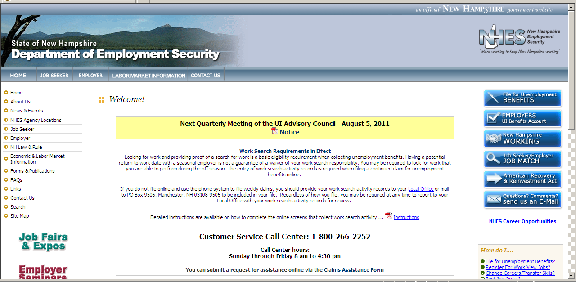

- Click the blue File for Unemployment BENEFITS box located on the right side of the page.

- You will be brought to the main claims page. If this is the first time you have visited our website, you must register before you can file your continued claim. Use the Create New Account (Register) link to register. If you have already registered, use the Existing User Log-in link to continue. Both links are located on the left side as well as at the bottom of the page.
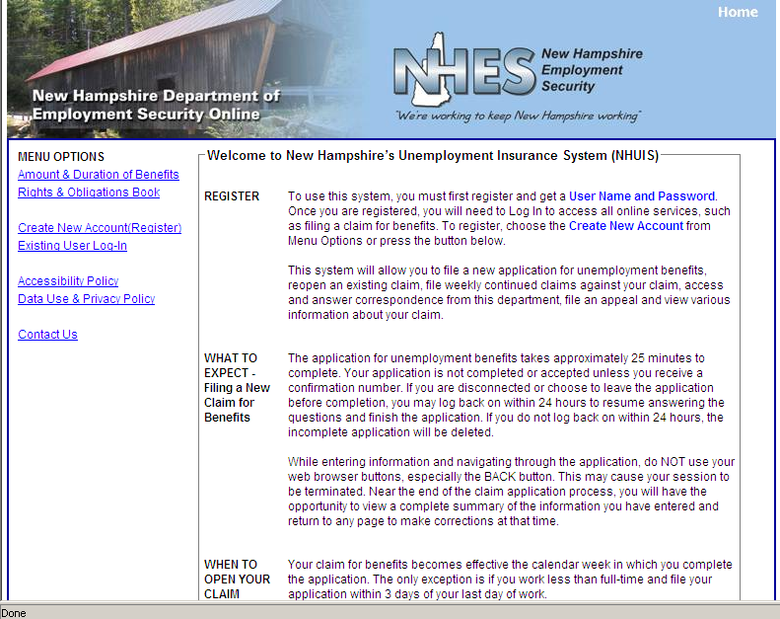

NHES 0168
N-8-11

- You will be brought to a screen and must choose whether to proceed in English or Spanish.
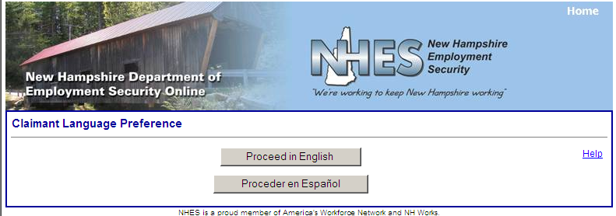

- Claimant Login Screen.
Enter your social security number twice in the User Name boxes.
Enter your Password, which you created when you registered.

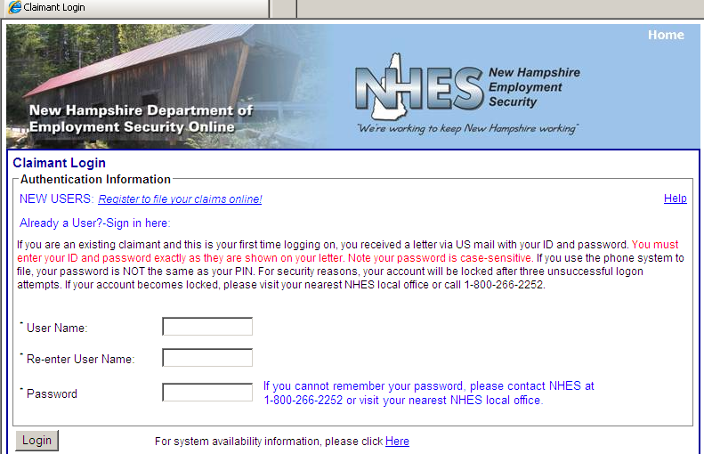

- You will be presented with your personal Main Menu. To file a continued claim, click the date link displayed on the left side of the page. The date displayed will be the previous week ending date. For example, if today’s date is 10/10/2011, then the date link will be 10/8/2011. (If there is no date link displayed on your Main Menu, there is no timely continued claim that can be filed. Contact the Call Center 1-800-266-2252 or report to your Local Office for assistance.)

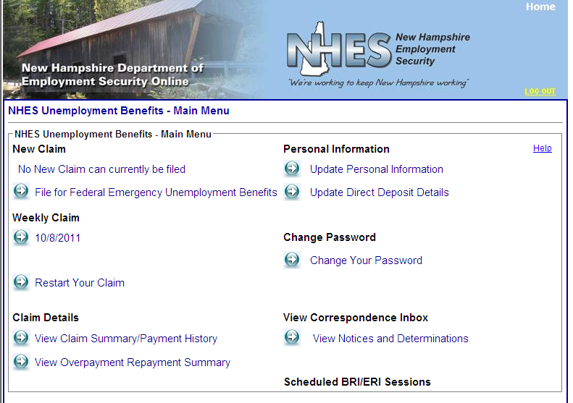

- A Continued Claim Application will be presented. Answer all questions presented. Choose Yes or No button, or enter the information requested.

It is important that if you received holiday pay for the week you are claiming or worked during the week you are claiming, you report it accurately and provide the gross amount of any payment (before any deductions).

If you worked but do not know the gross amount of payment, say YES to working but leave the amount field blank. The week can not be paid until you provide the gross amount of payment to this department, which can be done by phone to the Call Center (1-800-266-2252 and speak with a customer service representative), or by going to or calling your Local Office. There is no automated method to report monies if you do not report when you are filing the week.

Once all questions are answered, click the NEXT button at the bottom of the page.

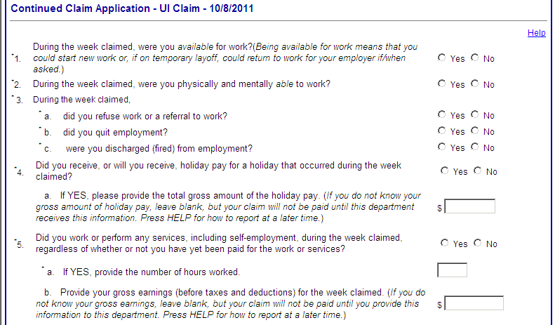
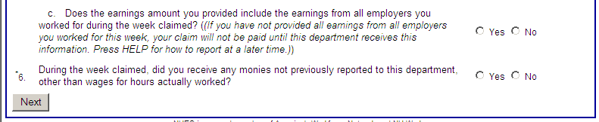

- If you are required to look for work, you must enter your worksearch efforts as part of filing your weekly continued claim. Click the ADD button and complete the form for each different worksearch contact or activity. Enter all attempts you have made to find work. There is no limit to the number you may enter and you should enter more than one to show a reasonable search for work. You may be required to report to the Local Office for a worksearch record review at any time. Keep copies of all worksearch activities, even those you did not list, as you will be asked to bring them with you.

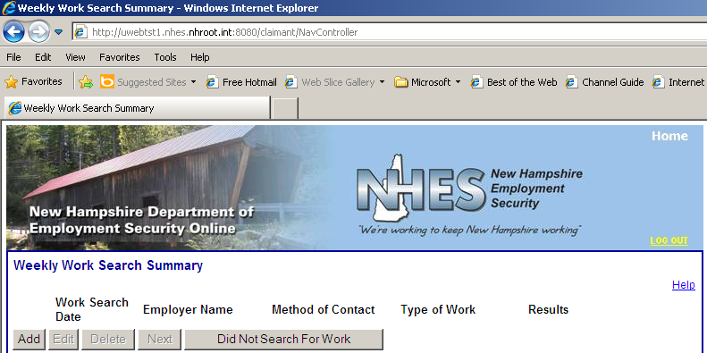

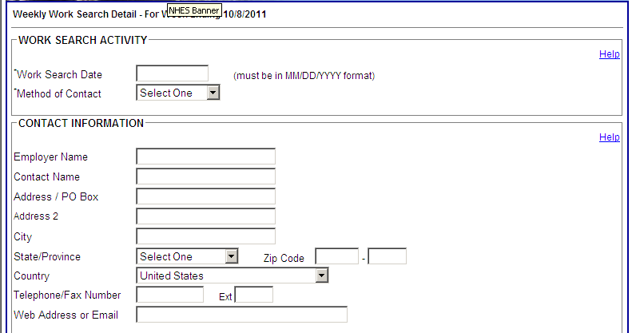
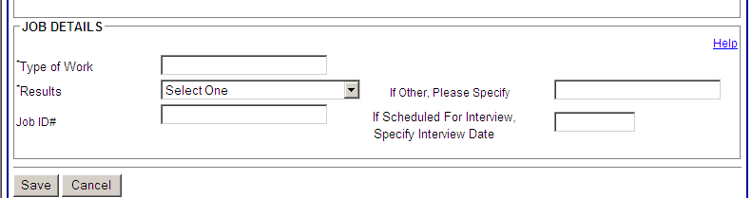

- When you have finished entering your worksearch record, click the SAVE button at the bottom of the page. You will be returned to the Weekly Work Search Summary and can click ADD as many times as necessary to continue to add records. Once you have entered and saved all records, click the NEXT button at the bottom of the Summary page.

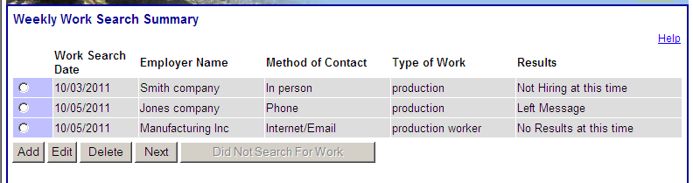

If you did not look for work during the week you are claiming and don’t have any activity to enter, click the DID NOT SEARCH FOR WORK button instead of the ADD button.

NOTE: If you miss any required information while answering questions or entering information, a red warning message will be presented when you click the NEXT or SAVE button. Enter the missing information and click the NEXT or SAVE button again.

- You will be presented with the Certification Page with a chance to review your answers. Choose one of the radio button statements at the end of the page.

If you choose “I agree to all of the above and wish to submit my claim for processing”, your weekly continued claim and worksearch activity records will be saved and sent for processing.

If you wish to change any of your answers or amend your worksearch records, choose the appropriate radio button and you will be taken back to the appropriate screens.

If you want to delete everything and start over, or have decided not to file at all, choose the “I do not agree and choose not to file for this week” button.

Once you have chosen one statement, click the NEXT button at the bottom of the page.

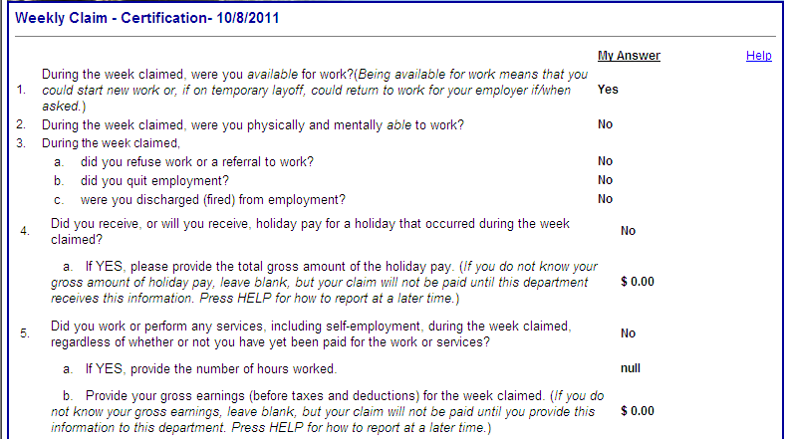
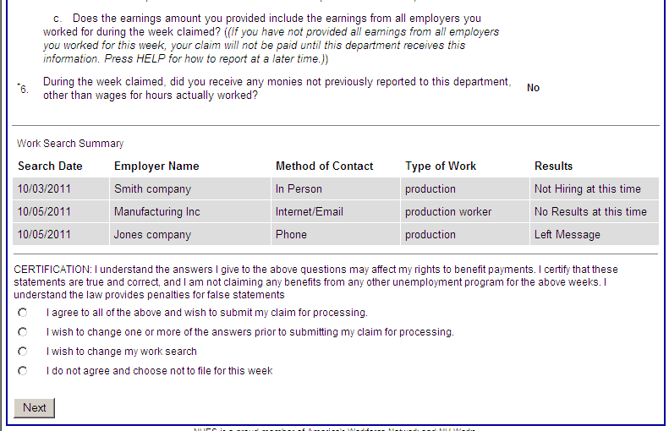

- You will be presented with the Weekly Claim Confirmation page and provided with a unique Confirmation Number. This is a very important page. It is recommended that you print this page. To do so, click on Print Confirmation button, then the Print button on the computer you are using. If you are not able to print, please write down the Confirmation number.

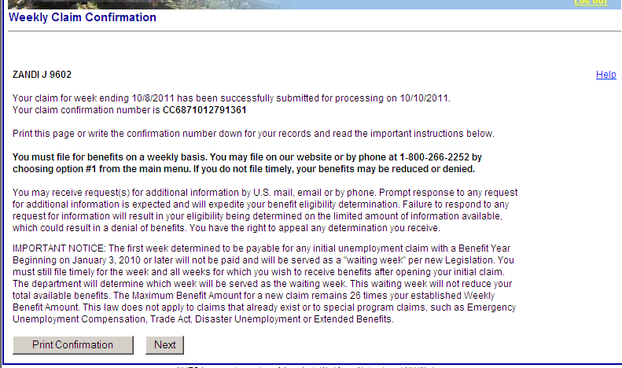

- If any additional questions are presented by the system, you may choose to answer them immediately, or respond later. Whether you answer them or not, your weekly continued claim has been filed as long as you chose the “I agree” statement and received a Confirmation Number.

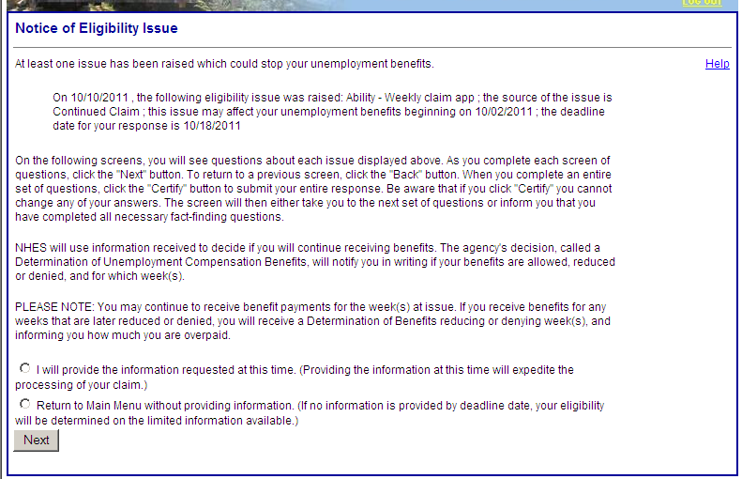

If you encounter problems, contact the Customer Service Call Center at 1-800-266-2252. The Call Center is open Sunday through Friday 8 am to 4:30 pm. You may also use the Online Assistance Form by using the Contact Us link at www.nhes.nh.gov or the main claims page.

NHES is a proud member of America’s Workforce Network and NH Works. NHES is an Equal Opportunity Employer and complies
with the Americans with Disabilities Act. Auxiliary Aids and Services are available on request of individuals with disabilities.

Telephone (603) 224-3311 Fax (603) 228-4145 TDD/TTY Access: Relay 1-800-735-2964 Web site: www.nhes.nh.gov

