Economic & Labor Market
Information (ELMI)
We have many Economic and Labor Market Information publications which you may find valuable in your job search. These can be found online at: www.nhes.nh.gov/elmi.
The Career Resources section of the ELMI website provides a Career Planning Guide, information about Top Career Prospects, and details about Licensed, Certified, and Registered Occupations in New Hampshire.
The website also includes our Economic and Labor Market Information database, NHetwork.
The NHetwork application provides information about: average hourly wages for occupations; licensing for certain occupations; employers names and addresses; projections for industries and occupations; educational and career information; and area profiles.
Publications of Interest
to Job Seekers
New Hampshire Occupational Employment and Wages Licensed, Certified, and Registered Occupations in NH Career Planning Guide
Projections to the Year 2022
Job Outlook and Locator
NHES Satellite Offices
Colebrook Satellite Office
118 Main Street, Colebrook, NH 03576
Telephone: (603) 237-5859
Exeter Satellite Office
St. Vincent de Paul
Community Assistance Center
53 Lincoln Street, Exeter, NH 03833
Telephone: (603) 772-9922
Franklin Satellite Office
Franklin Public Library
310 Central Street (2nd Floor), Franklin, NH 03235
Telephone: (603) 934-2911
Lebanon Satellite Office
Vocational Rehabilitation
85 Mechanic Street, Suite D2-1
Lebanon, NH 03766-1523
Telephone: (603) 543-3111
Plymouth Satellite Office
Whole Village Family Resource Center
248 Highland Street
Plymouth, NH 03264
Telephone: (603) 536-3720
Fax: (603) 536-1175
NHES Offices
Berlin
151 Pleasant Street, 03570-2085
Telephone: 752-5500 Fax: 752-5536
Claremont
404 Washington Street
P.O. Box 180, 03743-0180
Telephone: 543-3111 Fax: 543-3113
Concord
45 South Fruit Street.
P.O. Box 1140, 03302-1140
Telephone: 228-4100 Fax: 229-4353
Conway
518 White Mountain Highway, 03818-4205
Telephone: 447-5924 Fax: 447-5985
Keene
109 Key Road, 03431-3926
Telephone: 352-1904 Fax: 352-1906
Laconia
426 Union Ave., 03246-2894
Telephone: 524-3960 Fax: 524-3963
Littleton
646 Union St., Suite 100, 03561-5314
Telephone: 444-2971 Fax: 444-6245
Manchester
300 Hanover St., 03104-4957
Telephone: 627-7841 Fax: 627-7982
Nashua
6 Townsend West, 03063-1217
Telephone: 882-5177 Fax: 880-5256
Portsmouth
2000 Lafayette Road, 03801-5673
Telephone: 436-3702 Fax: 436-3754
Salem
29 South Broadway, 03079-3026
Telephone: 893-9185 Fax: 893-9212
Somersworth
6 Marsh Brook Drive, 03878-1595
Telephone: 742-3600 Fax: 749-7515
NH Employment Security is an Equal Opportunity Employer
and complies with the Americans with
Disabilities Act. Auxiliary aids and services are available
upon request of individuals with disabilities.
TTY/TDD ACCESS RELAY NH 1-800-735-2964.
NH Employment Security is a proud member
of America's Workforce Network & NH WORKS.
www.nhes.nh.gov
NHES 0321 R 2-15
EMPLOYMENT
SERVICES
&
RESOURCES
NH Employment Security has free
services, resources, and tools to help
you with the entire job search process!
We are interested in any comments
you have for improving our services.
Visit us to find a new job,
a better job, or your first job!
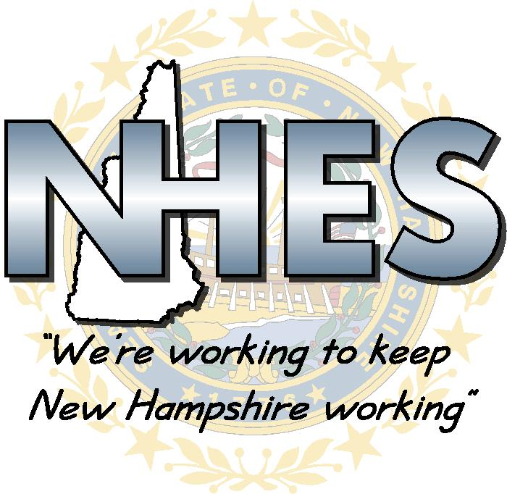
The NH WORKS System is a partnership between a number of government agencies and community organizations to provide services, resources, and information to employers and job seekers. The NH WORKS Center delivers these services and information and is located within NH Employment Security Offices across the State. NH Employment Security's Resource Centers are an integral part of the NH WORKS System. Information about the NH WORKS System is at www.nhworks.org

NHES Resource Centers
A wide range of services, tools and resources are available for everyone in the NH Employment Security (NHES) Resource Centers, an integral part of the NH WORKS System. Newspapers, books, videos and many other publications are available. You may use work stations to work on your résumé or cover letter, research employers or careers and view videos. Please ask the Center Coordinator for assistance with any employment related activity offered.
Employment Opportunities
Job Matching System - Our job match system is available on PCs in the centers. The system matches applicant résumé registrations with employer job listings using skills, job requirements or other related data.
Internet Access - Access to other employment related sites on the Internet and to NH Employment Security's Web Site. We link to many sites for job seekers.
Help Wanted Ads - Ads are located on the newspaper
rack in the Center or can be accessed via the Internet.
Career Development & Job
Search Assistance
Résumé/Cover Letters - Use a PC to access the Job Matching System, designed especially for your ease in résumé/cover letter preparation. We also have books and videos available to help you with the preparation of your résumés and cover letters. You can print your résumé and make some copies.
Video Library/TV/DVD - A TV, DVD and headset is available to view employment related videos.
Library - Employment related books are available
in our library which cover topics from résumés/cover
letters, networking, the Internet and career research.
O*NET - Use O*NET for career information, transferable skills assistance, information on colleges and technical schools and financial aid data.
Social Media – Special events like Job Fairs and
Recruitment Events are posted on Facebook and Linked-in.
Job & Resource Fairs/Recruitment Events - If you are an employer or resource agency interested in attending, simply fill out the registration form that is attached to the Job Fair you want to attend and submit them through the Job Fair email. There are no
fees for registering for the Job Fairs. If you are a job seeker, you do not need to register for the Job Fairs. To stay up-to-date on future Job & Resource Fairs or Special Events visit:
http://www.nhes.nh.gov/media/job-fairs/index.htm
Additional Services
- Copy machine
- Fax
- Ask for our Job search workshops schedule
- Telephone Stations are available for calls to local employers
Assistive Devices
- Television with DVD
- Hearing Helper Assistive Listening Device
- Ultra TEC TTY machine
- ClearView 300 OPTELEC Magnifier
- Romeo 25 Braille Printer
- Epson Perfection 1660 Photo Scanner
- Computer with large print keyboard
- Vertical adjusting desk top
- Track ball mouse
- Speakers with adjustable volume
- Headphones with ear covers
- Jaws DBT
- DBT - Tutorial for Braille Users
- Open Book-Reading and Scanning Software
- Zoom Text Xtra with magnification, speech program, & document reader
Are you a Veteran?
Veterans and eligible spouses receive access, on a priority of service basis, to the full range of public employment and training services, including job search assistance, workshops, résumé assistance, labor market information, career guidance, job referral, and referral to other supportive and training resources. Veterans are given preference in each of our local offices in the referral to job orders. Staff assesses the needs of each veteran and makes it a priority to educate the veterans of New Hampshire on services available through NHES. If you are a Veteran or eligible spouse, please identify yourself as such when inquiring about any NHES programs or services or upon visiting a NH Works office. By doing so, you will be able to take full advantage of this priority.
Re-Employment Services
If you would like one-on-one assistance, ask for an Employment Service Representative. The Employment Service Representative helps with job/career and vocational choice, change, adjustment, direction, and transition.
Return To Work program
Allows unemployed NH residents up to 6 weeks of training (up to 24 hours per week). Eligible claimants may continue receiving their unemployment benefits.
Job Search Workshops
Topics covered include: résumé and cover letter writing; the job interview; interviewing skills and techniques; using the Internet as a job search tool; social media; navigating a job fair; networking and exploring other leads in addition to the newspapers; and the entire job search process.
Unemployment Compensation
If you are out of work or your hours have been reduced, it is your right to open a claim and file for Unemployment Compensation Benefits. If you have worked in New Hampshire anytime within the last 18 months, regardless of where you now live, file on-line at https://nhuis.nh.gov/claimant. If you do not have Internet access, please visit your local office to file. If you have not worked in New Hampshire within the last 18 months, please contact the state in which you last worked to file for benefits with that state.
NH WORKS System
What can it do for you?
- 211
- Fuel Assistance
- Food Stamps
- College courses
- Training
Or if you:
- Have a disability
- Are a veteran
- Are long term unemployed
- Are economically disadvantaged
- Are an older worker
- Are a student/youth
- Have other barriers to employment

